Lab 2

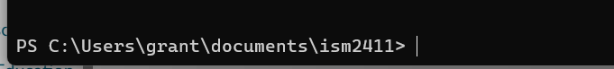

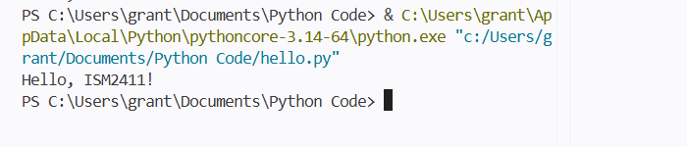

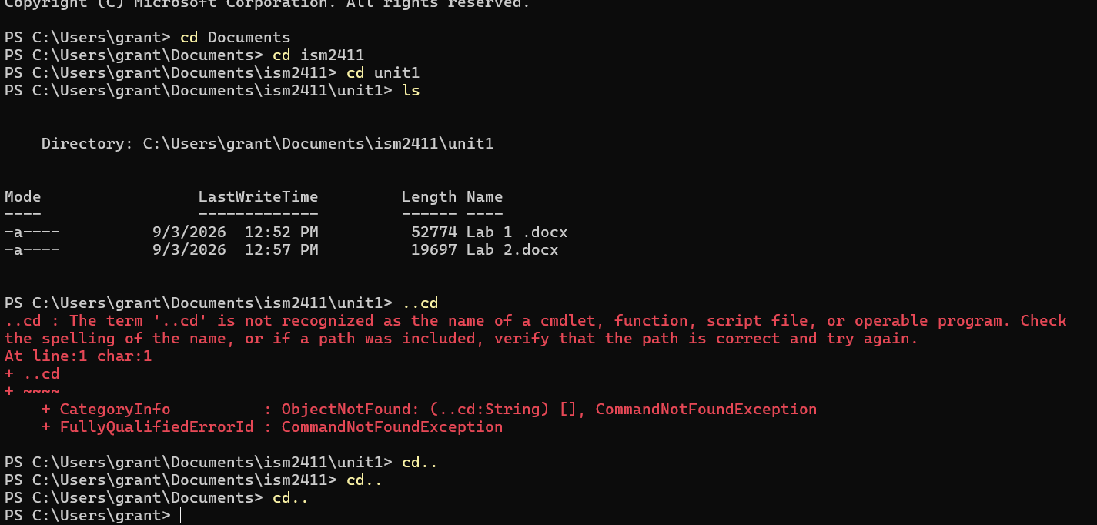

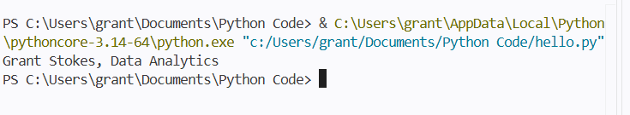

Traceback (most recent call last):
File "c:\Users\grant\Documents\Python Code\hello.py", line 1, in <module>
primt("Grant Stokes, Data Analytics")
^^^^^
NameError: name 'primt' is not defined. Did you mean: 'print'?
Means what I was asking it to do does not exist and the way to fix it is to replace primt with print.

.
Fails with "No such file or directory". This is because I was not calling the directory correctly.

It works the second time because I tell the code directly where to run the code which file is already made.

